700106 / 700120 Lab Book

Week 9 – Lab I

**Exercise 1. Render to texture  
Question:**

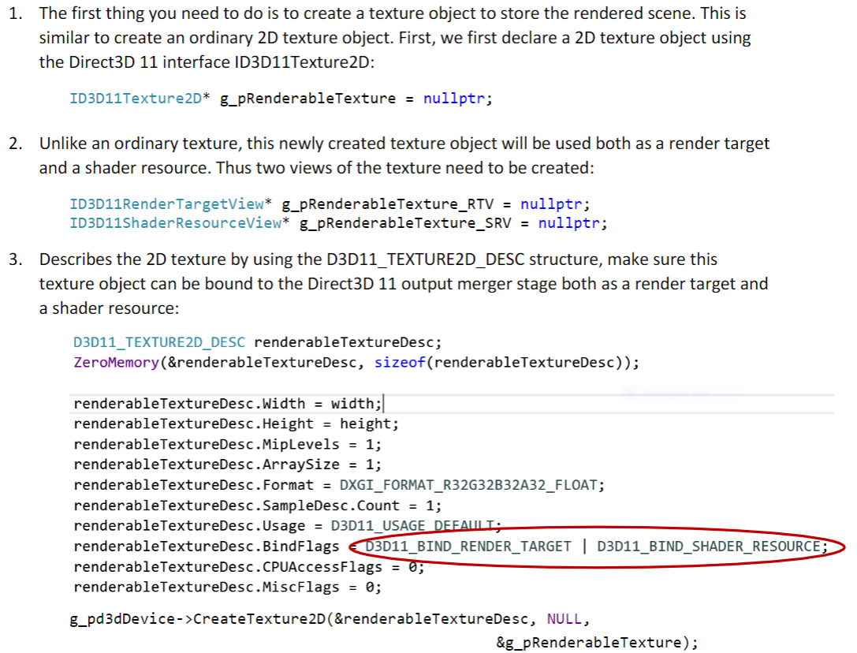  
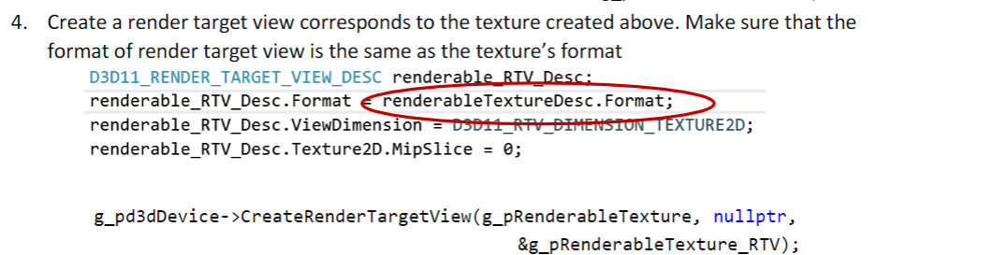  
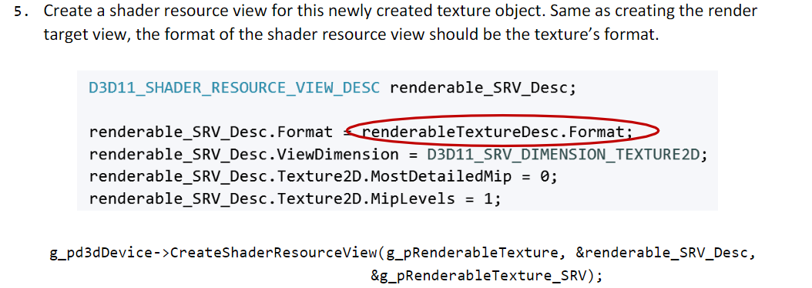

**Solution:**

1. As mentioned in the question follow the steps.

Firstly, add the variables that are required for the task, which is shown below.

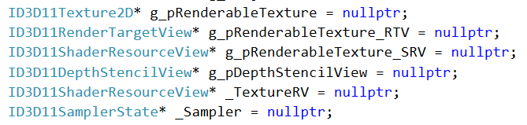

Then, define the renderable texture.

Add the render target view.

Next the Shader resource view.

Load the texture.

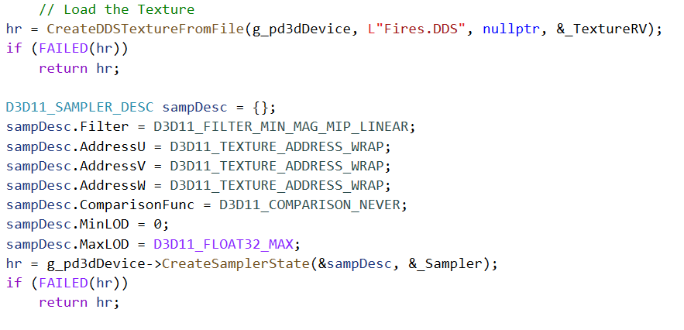

Finally, modify the render() as given below.

**Sample output:  
**

**Reflection:** In this assignment, I got to know about the render to textures.

**Exercise 2: Texture smoothing.**

**Question:**



**Solution:**

1. Firstly, will be using same code as first assignment and the modification will be done on the pixel shader.

Use the smoothing techniques, which is given below.

**

**Reflection**: As in the previous exercise, here we are doing smoothing to the same cube using one of the smoothing technique which is given in the above screen shot.

**Exercise 3. Glowing Effect.**

**Question:**



**Solution:**

**1**. Firstly, will be using the second exercise code to achieve this and will be modifying the pixel shader, which is given below.

**Sample output:**

**Reflection:**

In this assignment got to know about making the objects glow by combining the smoothed object and original texture.

**Exercise 4. Object on fire animation**

**Question:**



**Solution:**

**1**. In this exercise will be using same code, and the modification will be in pixel shader to animate like fire, which is given below.

**Sample output:**

**Reflection:**